**Oracle SQL Queries**

**--1 To count the number of movie according to the genre.**

SELECT G.TYPE, count (M.MOVIEID) MovieCount

FROM MOVIES M

INNER JOIN MOVIE_GENRES MG

ON M.MOVIEID=MG.MOVIEID

INNER JOIN GENRE G

ON MG.GENREID=G.GENREID

where M.rating>8

group by G.Type

order by count (M.MOVIEID) desc;

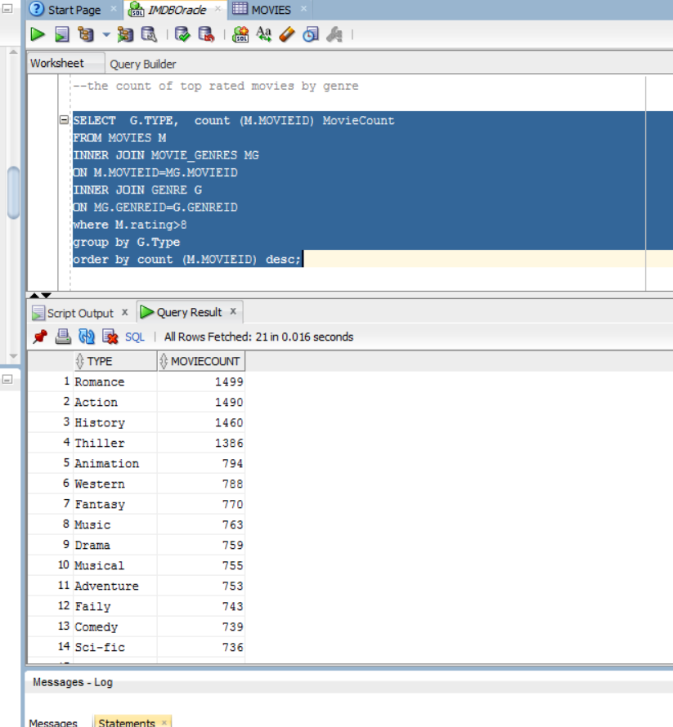

**--2 To count the number of top rated movies released between 2008-2016**

select count(M.MOVIEID)as MovieCount, EXTRACT(YEAR FROM M.RELEASEDATE) as ReleaseDate

from movies M

where EXTRACT(YEAR FROM M.RELEASEDATE) between 2006 and 2016

and rating>6

Group by EXTRACT(YEAR FROM M.RELEASEDATE);

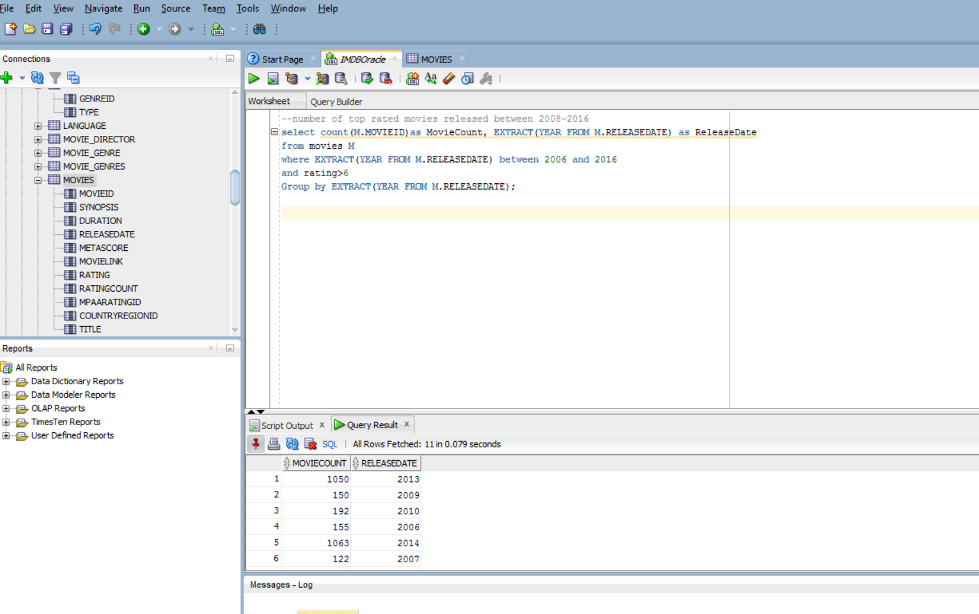

**--3 To select number of tickets sold by popular showtimes.**

select count(Bookings.BookingID) as TotalTicketsSold,Showtime.StartTime as Showtimes

from movies

inner join showtime

on movies.MovieID=Showtime.MovieID

inner join Ticket

on Showtime.ShowtimeID=ticket.ShowtimeID

inner join Bookings

on ticket.TicketID=bookings.TicketID

group by showtime.StartTime

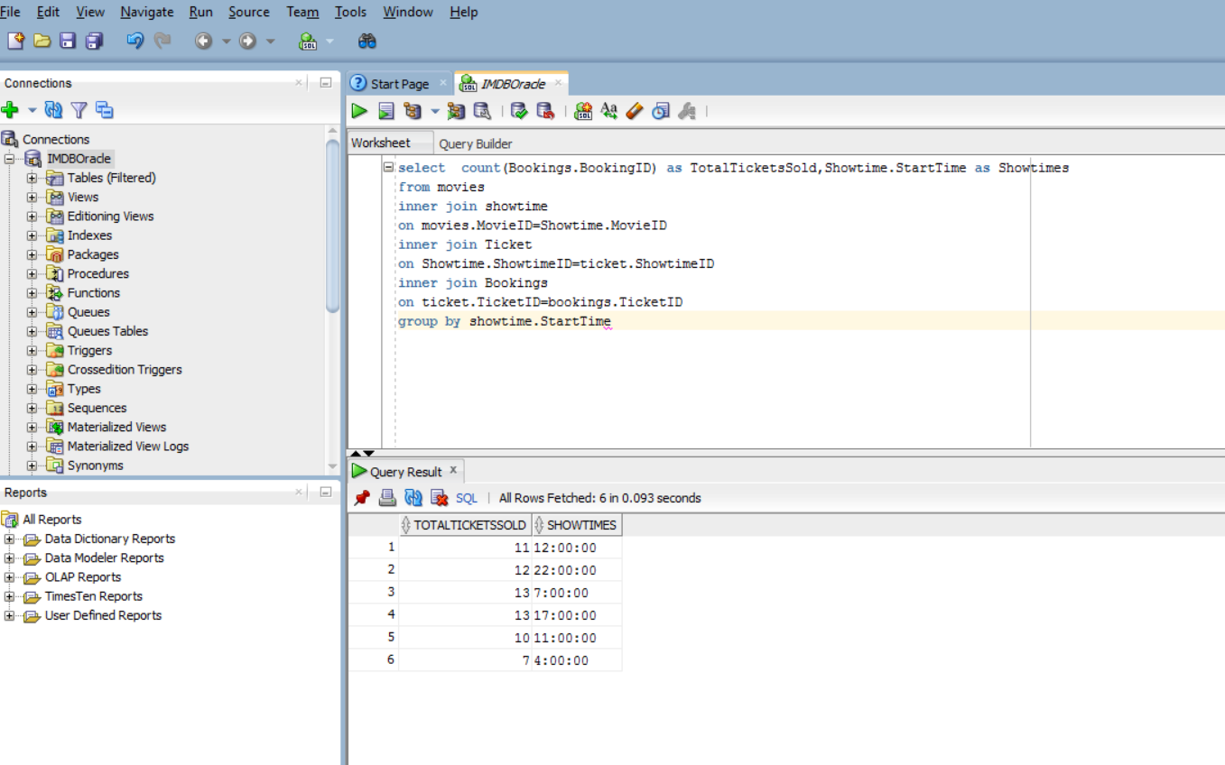

**--4 To count number of movies released in a particular language**

Select Language.LANGUAGE_NAME as Language,count(movies.MOVIEID)as CountofMovies

from movies

inner join Movies_Language

on movies.MovieID=Movies_Language.MovieID

inner join Language

on Movies_Language.LanguageID=language.LanguageID

group by Language.Language_Name

